ERSMS, Group F, Project Architecture

Changelog

Changes Date | Author | Description
08.03.2024 | Kuba Mazur | Created document
11.05.2024 | Krzysztof Rudnicki | fixed spelling, added comments

Requirements

Database
- We have to save Q5 history of database changes (for rollbacks)
- We have to create physical partitions of database (we can have base of millions of movies, it may not be stored on one disk, except of this number of users can be counted in millions and we have to store all data involved)
- We need to have backups of data (if restoration by changes rollback is impossible)
- Database need to be prepared for moderate number of moderate data selection

AI solution
- Need database access ✅
- Potentially the bottleneck (due to nature of AI programs)

Web Service
- Services must manage thousands of requirements in minutes.
- Need direct access to databases and AI instances. ✅
- Require OAUTH ✅

Visualization of architecture

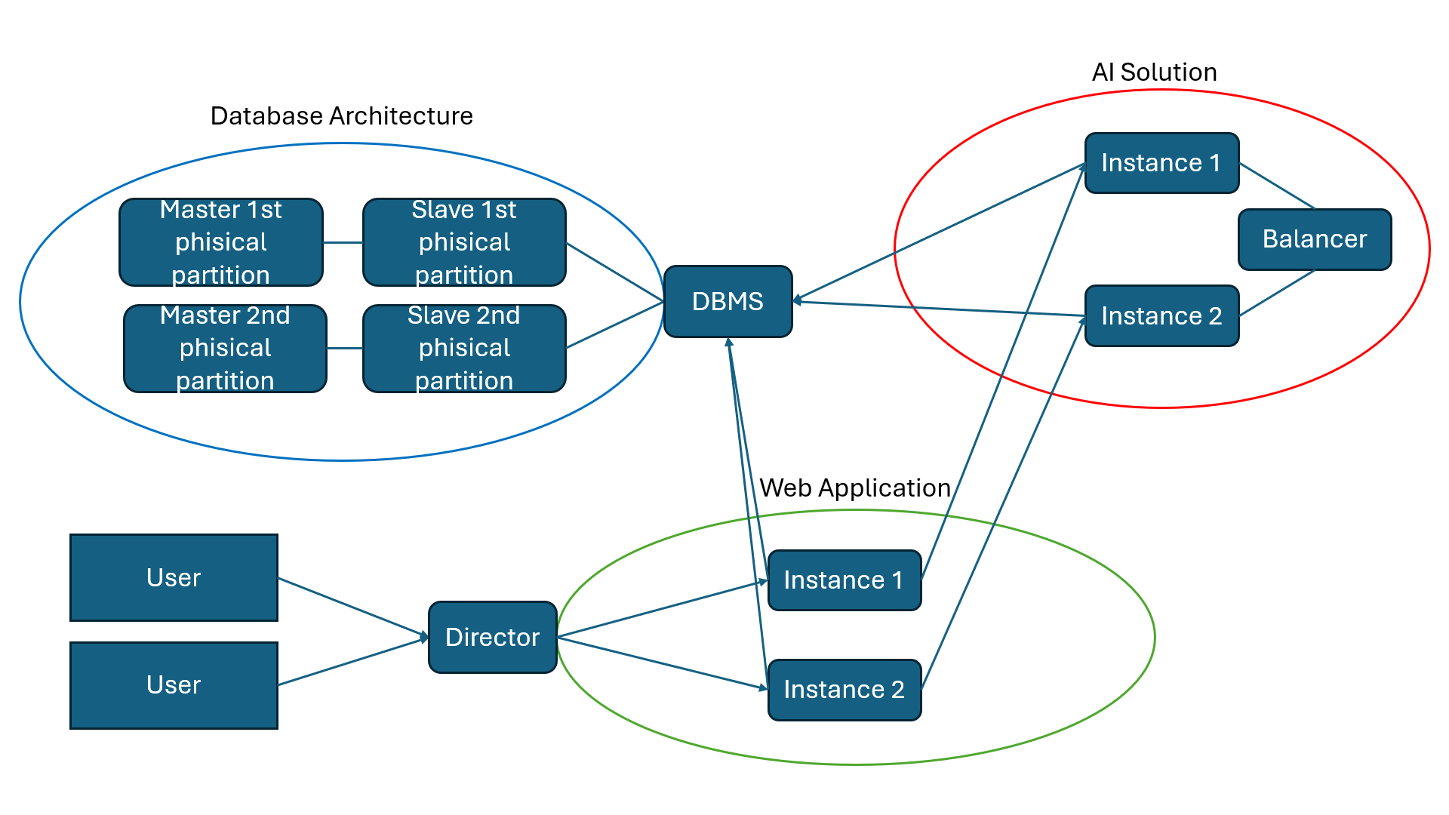

Architecture Description

First step
- Users connect to the directory instance whose address is recorded in DNS.
- Director direct connection to instance of web application

From main page
- OAuth is available to connect to account or it can be done via normal login password option

On user account
- Users can get information about movies from the database. ✅
- Based on history of searching and ratings, ai recommended movies can be found and displayed ✅

Web application
- Every instance of a web application should have a cache which stores data of most searched movies and recommendations for the latest active users. ✅

AI Solution
- AI solution instances should have caches of data of movies which are most crucial for recommendation ora re used for the biggest number of recommendations ✅
- If required, one instance of a web application can send requests to more than one AI solution instance.

Database
- Databases should have at least 2 physical partitions due to the number of data.
- Databases require a primary and at least one secondary for safety of kept data. (If secondary was purified, primary would be backup)

Potential problems
- Problems on director can affect the whole system, unless switches are available for redirection on a lower level. ✅
- Updating AI solution models requires much more time than anything. ✅

