Kuba Mazur, RSMS, Project Architecture

Requirements

Database
- We have to saveQ5 history of database changes (for rollbacks)
- We have to create phisical partitions of database (we can have base of milions of movies, it may not be stored on one disk, except of this number of users can be counted in milions and we have to store all data involved)
- We need to have backups of data (if restortion by changes rollback is impossible)
- Database need to be prepered for moderate number of moderate data selection

AI solution
- Need database access
- Potentialy the bottleneck (due to nature of AI programs)

Web Service
- Service need to manage thousands requirements in minutes.
- Need direct accees to database and to AI instances.
- Require OAUTH

Visualisation of architecture

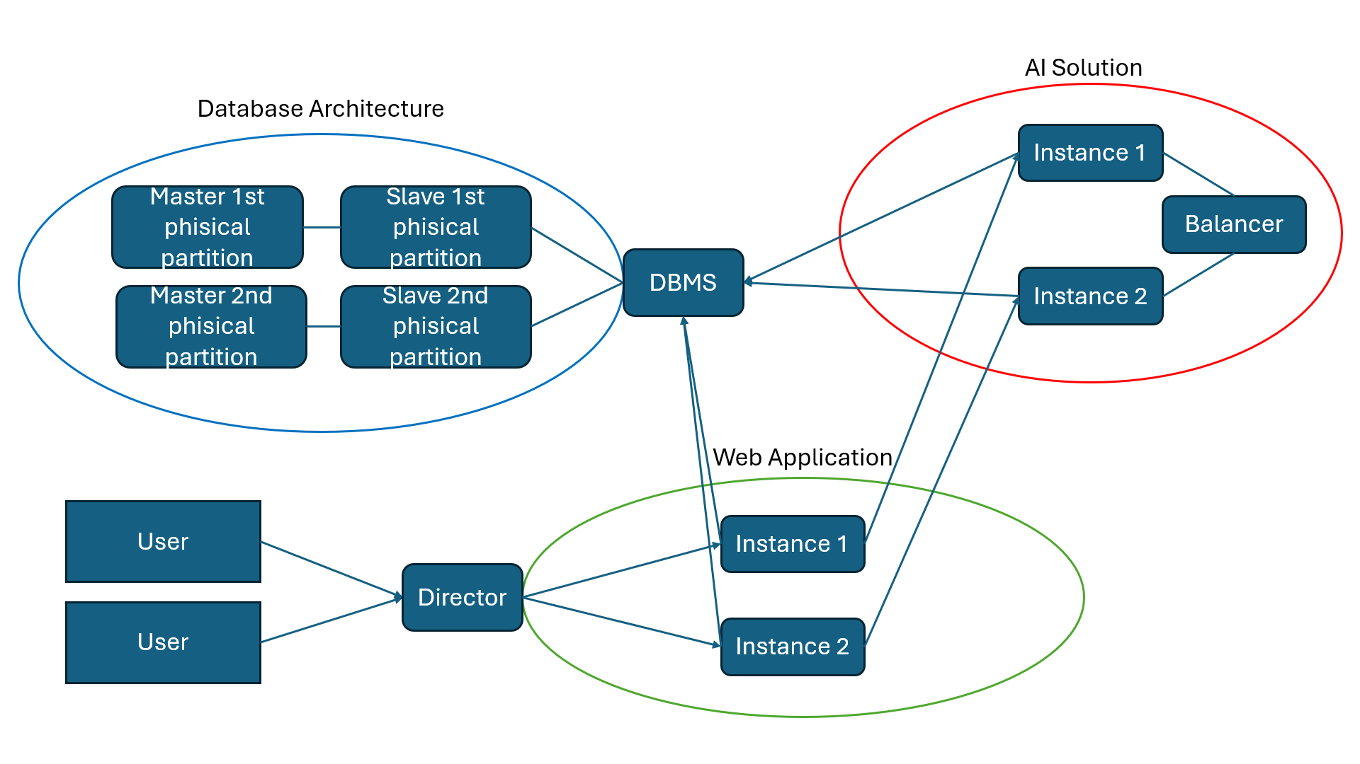

Architecture Description

First step
- Users connect to director instance which adress is recorded in DNS.
- Director direct connection to instance of web application

From main page
- OAuth is aviable to connect to acount or it can be done via normal login password option

On user account
- User can get information about movie from database.
- Due to history of searching or preferences form preferenced movies can be found and displayed

Web application
- Every instance of web application should have cache which store data of most searched movies and recomendation for lattest active users.

AI Solution
- AI solution instances should have caches of data of movies which are most crucial for recomendation ora re used for the biggest number of recomendations
- If required, one instance of web application can send requests to more than one AI solution instance.

Database
- Database should have at least 2 phisical partitions due to number of data.
- Databse require master and at least one slave for safety of kept data. (If slave was puryfied, master would be backup)

Potencial problems
- Problems on director can affect whole system, unless swiches are aviable for redirection on lower level.
- Update of AI solution models require much more time than anything else.

